Alaska Indoor Gardening Curriculum

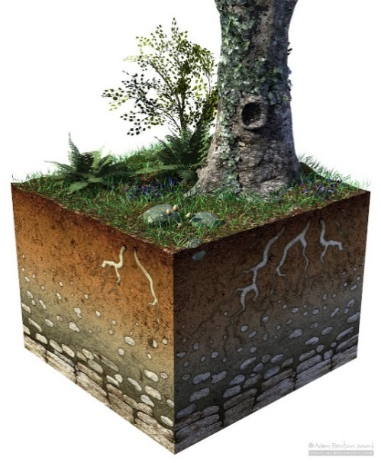
Garden Soil Exploration Lesson

Author/Source(s): Mel Sikes, Alaska Agriculture in the Classroom
kidsgardening.org and agclassroom.org

Suggested Grade Levels: All Levels

Time: 45 minutes to 1 hour per Section

Teaching Goals:
Students will learn about the components and structure of soil.
Students will learn how healthy soil will insure healthy plants.
Students will understand the correlation between good soil drainage and healthy plant growth.

Learning Objectives:
To investigate soil particle size by exploring the different components of soil such as sand, silt and clay.
To investigate how water drains through different types of soil by setting up a drainage experiment.

Core Ideas:
- Introduction to Soil Composition and Types
- Plant soil nutrient needs
- Hydrology – water cycles
- Geological Creation of Soil
- Agriculture
- Composting
- Field Testing of Soil – Ribbon Test
- Engineering – Constructing Soil Drainage Systems
- Standardized Science Measurements
- Recording Scientific Data in Tables
- Small Scale construction of a Compost System
- Drawing Conclusions from Experimentation

Alaska Science Standards: K-LS1-1, K-2-ETS1-2, 1-LS1-1, 2-LS2-1, 2-PS1-4, 3-LS4-4, 4-ESS2-1, 5-PS3-1, 5-LS1-1
5-LS2-1, MS-LS1-5, MS-LS2-1, MS-LS2-3, HS-LS1-5, HS-LS2-3, HS-ESS2-2, HS-ESS2-7

NGSS Standards: K-LS1-1, K-ESS2-2, K-ESS3-1, 1-LS1-1, 2-LS2-1, 2-PS1-2, K-2-ETS1-3, 3-LS3-2, 4-ESS2-1, 5-PS3-1
5-LS1-1, 3-5-ETS1-1, MS-LS1-5, MS-LS2-1, MS-LS3-3, MS-ETS1-1, HS-LS2-6, HS-ESS2-6, HS-ESS2-7, HS-ESS3-4, HS-ETS1-1

Materials Needed:
- Three to four samples of different outdoor soils and store-bought potting soils – enough for each group to have at least ¼ to 1/8 cup. Label these samples A-D.
- Pure Sand, Silt and Clay Samples – enough for each group to have 1/8 cup each.
- Paper Plates
- Magnifying Glasses
- Water
- Small cups to hold water
- Timers – one per group or pair of students
- Paper Towels
- 2 Liter Soda Bottles cut for experiment (see diagram), enough for a few experiments comparing two soils.
- Sponge, two pieces cut to fit in mouth of the bottles
- Soil Drainage Experiment Worksheet
- Pencils, sharpies

Vocabulary:
- Clay: the smallest of the three soil particle sizes; measuring less than 0.002 mm.

- Loam: soil that has a roughly equal mix of sand, silt, and clay mineral particles.

- Organic Matter: the dark, lightweight component of soil that is formed when leaves and other plant and animal-based materials decompose.

- Rock: the solid mineral material that forms part of the earth’s surface.

- Sand: the largest mineral soil particles, measuring between 2.00 and 0.05 mm.

- Silt: medium-sized mineral soil particles, measuring between 0.05 and 0.002 mm.

- Soil: a mixture of minerals, organic matter, water, and air, which forms on the land surface and can support the growth of plants.

- Texture: surface characteristics that can be seen or felt.

Background for Teachers:
Soil is the foundation for agriculture. We need soil to grow the plants we eat, the plants we wear (cotton and linen), the plants that provide us materials to build shelter, and the plants we use for thousands of different applications. Soil is composed of four elements: air, water, organic matter (decomposed material from once-living organisms), and non-living mineral particles (tiny pieces of weathered rock).

Soil is a natural resource consisting of weathered rock particles, organic matter, air, and water.
Soil is considered a non-renewable resource because it does not renew itself at a sufficient rate in the human time frame. One centimeter of soil can take hundreds to thousands of years to form from parent rock.

There are many different types of soil around the world. One simple and informative way to classify soils is by texture, which is determined by the size of the mineral soil particles. Soil particles come in three sizes: sand, the largest, followed in descending size by silt and clay. Clay is so small that the particles are actually impossible to see without magnification. Amazingly, you can feel the difference! A sandy soil feels gritty, and a clayey soil feels smooth and sticky. A soil with a mixture of all three particle sizes in about equal proportions is called a loam. This is the most desirable texture for growing crops because it holds just the right amount of water—not too much and not too little.

The texture of a soil determines how water will move through it. Water moves through clay very slowly because the spaces between the particles are very small, and the particles themselves actually attract water. Once wet, a clayey soil will take a long time to dry out. Nonetheless, it can be difficult for plant roots to access the water that is tightly held in clayey soil. In contrast, water moves very quickly through sandy soil. This means that the water is easy for plant roots to access, but the soil can dry out very quickly, leaving plant roots dry and thirsty if water isn’t applied frequently.

Air exists in the pore spaces between the soil particles. When a soil is dry there is more air in the soil, but when wet, there is very little air in the soil because the water has filled in the spaces! Soil is rarely completely dry; there is usually at least a small amount of moisture in soil. Some plants are aquatic and thrive in saturated soils, but many others do not. Most land-based plants need air in the soil to grow.

Soil is composed of minerals and organic matter. Sand, silt, and clay are the mineral particles derived from rock broken down over thousands of years by climatic and environmental conditions (rain, glaciers, wind, rivers, animals, etc.) The largest, coarsest mineral particles are sand. Silt particles are finer and feel similar to flour. Clay particles are extremely fine and feel sticky in your fingers when wet, and clump to the point that you can't see an individual particle without a microscope. The proportion of these three particle sizes in a soil determines its texture or the way the soil feels.

Sandy soil is made up of large round particles with relatively large spaces of air between them. Though sandy soil contains a lot of air, or space it cannot hold water well and tends to lose soil and nutrients quickly.

Silty soil is intermediate in texture between clay and sand. It feels smooth and is slippery to the touch when wet. Silt prevents water and minerals from the leaching, or draining out of the soil.

Clay soil is made up of microscopic, flattened mineral particles. These tiny particles pack closely together, becoming sticky when wet and leaving little space for air and water.
Clay soils have poor drainage and air holding spaces. Because of this, clay and other heavy soils often hold more water than is good for plant growth. On the other hand, clay soils may be richer in nutrients, because they can hold plant minerals more effectively than soils composed of larger particles. Farmers, gardeners and anyone else growing plants need to know what kind of soil is present. For example, sandy soils require less fertilizer and more frequent applications of water than clay soils.

Organic matter is the decayed remains of once-living plants and animals. Organic matter brings nutrients to the soil and helps provide much needed pore space to allow air to reach the roots of the plant and provide areas for root growth. Soil is teeming with life, including microorganisms like bacteria and fungi (billions in a single teaspoon!) and larger animals such as worms, beetles and centipedes. Many of these underground inhabitants feed on remains of plants and animals, breaking down their tissues. In the process, they create pore space and release nutrients that plants need and the cycle begins again.

Compost is organic material that can be added to soil to help plants grow. Food scraps and yard waste currently make up 20 to 30 percent of what we throw away, and should be composted instead. Worms can be used to help process food waste to create a nutritious soil additive. Composting can occur without worms, but worms do speed up the process. Microscopic organisms in compost help aerate the soil, break down organic material for plant use and ward off plant disease. Compost offers a natural alternative to chemical fertilizers.

Perlite: When you look at most garden soils you will notice white roundish particles throughout the soil. Perlite is mainly composed of minerals that are subjected to very high heat, which then expand it like popcorn so it becomes very light weight, porous, and absorbent. Perlite has a neutral pH, excellent wicking action, and is very porous. It helps the soil both retain water and creates air spaces. Roots need air as much as they need water; plants can actually suffocate or drown if they are completely submerged in water for extended periods of time.
(Information adapted from a soil composition lesson on Kidsgardening.org and the National Ag in the Classroom “Texturing: The Big Picture” Lesson)

Ribbon Test: The ribbon test is a term used by the scientific community to describe tests that can be done in the field to determine the components in the soil. https://www.youtube.com/watch?v=GWZwbVJCNec

Procedure:

Activity one: Soil Exploration
- Ask and discuss: What is soil? What is dirt? Students may suggest that dirt implies something that is unclean, but the word soil invokes growing medium and full of life. Soil is ALIVE! Ask students if all soils are the same and guide them to agree that soils are different. Ask them how soils might be different.

- Share information about soil and how it relates to gardening, the components of soil and how the amount of sand, silt and clay present effects growing conditions for plants.

- Ask the students how the soils might differ when examined more closely. You could do this as a class discussion or consider writing a grid on the board with the five senses or with just the senses you are emphasizing in this lesson. Students may share ideas that belong in the chart throughout the lesson and you can add them where appropriate. It could look like one of the examples below:

Smell | Taste | Touch/Texture | Look/See/Vision | Sound
OR
Touch/Texture | Look/See/Vision | Smell

- Show them different types of soil. Give them each group a sample on a paper plate to look at under their magnifying glasses. Have them identify the different things they observe about the soil. Students can add this to their chart at their desks if you choose to use the included grid. You could also record notes as a class on the board or ask the students to record this in their science journals, whatever is appropriate for your grade level.

- Talk about the color, texture, and smell of the soil. Let them explore the soil with their fingers, smell it, smear it to see sand and smaller particles. Explain how the marks left on the plate by the soil are from particles like silt and clay, sand will leave grooves in the plate but will not leave a dirt smear.

- Identify the perlite (white rocks in the potting soil), explain what it is and why it is in potting soils. (see background information).

- Have each student take the sample and perform the ribbon test to estimate the amount of each particle in your soil samples.

- First, take the small clump of soil into the palm and add a small amount water until it makes a moist ball. If the soil will not form a ball, the soil is composed of mostly sand. Don’t forget to remind your students to scrape the soil off their palms and back into the ball as they go.

- Rub the soil together between your hands and fingers. If the soil makes a nice, long ribbon, then it has a lot of clay in it (thus sticks together well). If it crumbles in your hand, then it has a lot of sand. If it is somewhere in between, then you probably have a good mix (a soil with a good mix of all 3 components is called a loam).

- Explain that the ribbon test may not be exact, but scientist may use it in the field to create a general description of a soil since it is very easy to implement (all you need is a little water).

Activity Two: Soil Drainage Experiment

- Ask students why soil needs to drain well. You want the students to remember that drainage is important for the roots. They need enough water to soak up and use to grow (photosynthesis) but also too much water will drown the plant. won’t get any water to soak up, or enough to help the plants grow.

- Present the students with soil choices, A-D, for the next part of the lesson. Without naming the soils or showing the soil labels if they are store bought, ask the students to make a prediction based on which would be the best to grow plants regarding drainage. If there’s time, allow groups to explore the soil further. You can consider having the entire class make the prediction or having individual groups make their own predictions. Either way, students making a prediction should be able to explain their reasoning and defend their ideas in front of the class.

- Use a sharpie to draw a line on the soda bottle at the point where it stops curving and goes straight. Cut the top off of the soda bottle and place it inside the bottom. Add a small piece of sponge into the mouth of the bottle. Depending on the age of your students, you may choose to do this in advance and provide students with the materials needed.

Diagram of the drainage experiment:

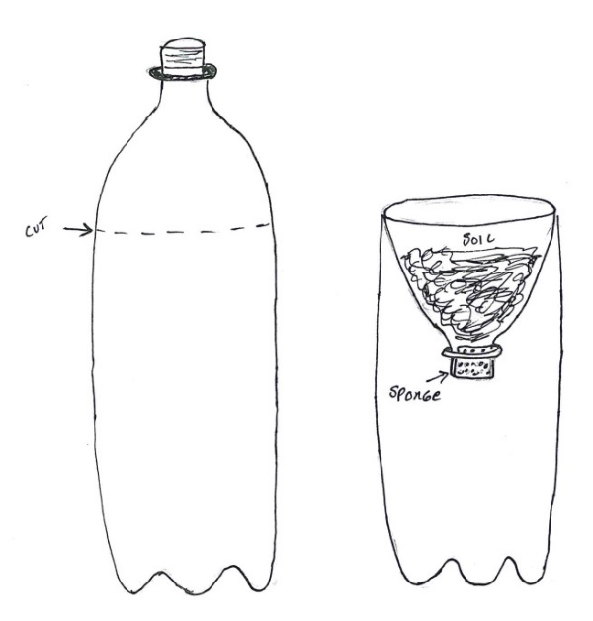

- Pick two types of soils and add ½ cup of soil to each bottle. Label the bottles, bottle A and bottle B. Have the students predict which one will drain faster, have them explain why. Each group will test 2 types of soil. Make sure that the soils are all represented in the classroom. Students must label the bottles with the soil selected.

- Measure out 1 cup of water into two plastic cups. Slowly pour the water into each bottle at the same speed. Have them use the timer to time how fast the water drains. Have them wait until the soil stops dripping.

- After the soil has finished draining, have students measure the amount of water in the bottom of each bottle and compare with how much water they initially poured.

- Have them decide which soil holds the water better. Have them put their findings on the Soil Exploration worksheet.

- Discuss as a class which soil type would be best for planting. Come to an agreement. Discuss why this would be important for the plants for the soil to keep the water longer. A good soil will have a balance of sand, silt and clay. Too much clay and the soil will not drain water well and could rot the roots if they stand in water too long. Too much sand will allow the water to drain too fast. Balanced soil particles and good drainage (not too fast or too slow) will contribute to healthy plants.

- Lesson Close: After conducting these activities, review and summarize the following key concepts:
- Soil is made up of many different components and particle sizes.
- Soil must have a mix of different components to be considered healthy soil.
- Good drainage is important to good soil.

- Clean Up!

Extensions:
- Plant Nutrients Lesson
- Hydroponic Plant Growth Lesson

Cross Curricular Ideas:
- Collect soil from different areas in your community for the students to test. For example, riverbanks, gravel pits, playgrounds, flower beds, etc. Then ask the students where it would be best to grow currently and where farmers and gardeners may have chosen to grow in the past.
- Consider asking a farmer or gardener to come talk to the students about how they change their soil so that it is more successful for their plants. Do they change the soil composition? Do they add chemicals?
- Students can bring soil samples from home. All samples gathered from the community can be mapped on a community map.
- Artists around the world have created amazing sculptures out of sand. If there is enough difference in color, you can consider having the students do an art project with sand in a bottle or make a soil mandala.
- Students can calculate how long it would take different amounts of water to drain through their soil, what would happen with twice, four times, 10 times as much soil – how much water would be retained, how much would drain out, how long it would take, etc.
- Students can write a paragraph(s) about their prediction and how successful it was, the procedure and process for the lesson, or how they might improve one of the soil samples so that it would grow plants more successfully.

Assessment:
- Assess the soil drainage experiment record keeping form at the end of this lesson
- Develop a checklist and monitor students for participation and comprehension as the lesson progresses
- Assess their science journals
- Have them write about their process and what they learned as a self-reflection after the lesson.

Resources
Books:
The Container Expert
by Dr. D. G. Hessayon 1998 ISBN: 0-903505-43-6

Dirt
by Steve “the Dirtmeister” Tomacek 2002, 2016 ISBN: 142632362X

Gardening Indoors with Soil and Hydroponics
by George Van Patten 2007 ISBN: 978-1-878823-32-8

Improving Your Garden Soil
by Barbara Perry Lawton 1992 ISBN: 0-89721-244-4

Life in a Bucket of Soil
by Alvin and Virginia Silverstein 2000 ISBN: 0-486-41057-9

SOIL! Get the Inside Scoop
by David L. Lindbo and others 2008 ISBN: 978-0-89118-848-3

Websites:
Food and Agricultural Organization of the United Nations : http://www.fao.org/soils-2015/faq/en/

National Association of Conservation Districts: http://www.nacdnet.org/education/soils
Soil Science Society of America: http://www.soils4kids.org/

Nutrients for Life Foundation: http://www.thescienceofsoil.com/

Soil Drainage Experiment

Name___________________________________________ Date____________

Investigate the different soils. Pick two types of soils and add a handful to each soda bottle. Add the same amount of soil to each bottle. Label the bottles, bottle A and bottle B. Predict which one will drain faster. Measure out an equal amount of water into two plastic cups. Slowly pour the water into each bottle at the same speed. Use the timer to time how fast the water drains, wait until the soil stops dripping. Repeat.

1 | Soil Type | Prediction | Amount of water before  pouring | Amount of water passed through soil | Observations
Soil A

Soil B

Conclusions:

2 | Soil Type | Prediction | Amount of water before  pouring | Amount of water passed through soil | Observations
Soil A

Soil B

Conclusions:

Soil Type | Texture/Feel | Soil Appearance | Smell
Sand
Silt
Clay
Loam
A
B
C
D

